**A RESPONSIVE PERSONAL PORFOLIO WEBSITE**

**A PROJECT REPORT**

# *Submitted by*

**Om Hari Shukla**

**12409254**

**48**

**K24EU**

in partial fulfillment for the award of the degree of

# BACHELOR OF COMPUTER SCIENCE AND ENGINEERING



**Lovely Professional University, Punjab**

**CSE326 – Internet Programming Laboratory**

**(CA-3)**

**NOVEMBER,2024**

# TABLE OF CONTENTS

|  |  |  |
| --- | --- | --- |
| **S NO.** | **TOPIC** | **PAGE NO.** |
| **1** | **Introduction** | **3** |
| **2** | **Technology Used** | 3-4 |
| **3** | **Workflow of project (Flowchart)** | 4-5 |
| **4** | **Project Description** | 5-6 |
| **5** | **Project Objectives** | 6-7 |
| **6** | **Expected Outcomes** | 7-8 |
| **7** | **index.html** | 8-10 |
| **8** | **about** | **10-12** |
| **9** | **services** | **12-14** |
| **10** | **porfolio** | **14-16** |
| **11** | **Contact**  **css** | **16-36** |
| **12** | **Output Screenshot** | **18-20** |
| **13** | **Github Repo Link** | **20-** |
| **14** | **References** | **61** |

|  |  |  |  |
| --- | --- | --- | --- |
| **15** | **Hire.html** | | **36-38** |
|  | |  |  |

# INTRODUCTION

**Hi, I’m Om Hari Shukla** a passionate web designer dedicated to transforming ideas into visually captivating, user-friendly websites.

With a strong eye for detail and a love for intuitive design,

I focus on creating digital experiences that are as functional as they are beautiful. From seamless navigation to engaging interactions, each project reflects my commitment to quality and creativity. Explore my work below, and let's bring your vision to life.

# TECHNOLOGY USED

* 1. HTML
  2. CSS
  3. JAVA SCRIPT

# WORKFLOW OF PROJECT

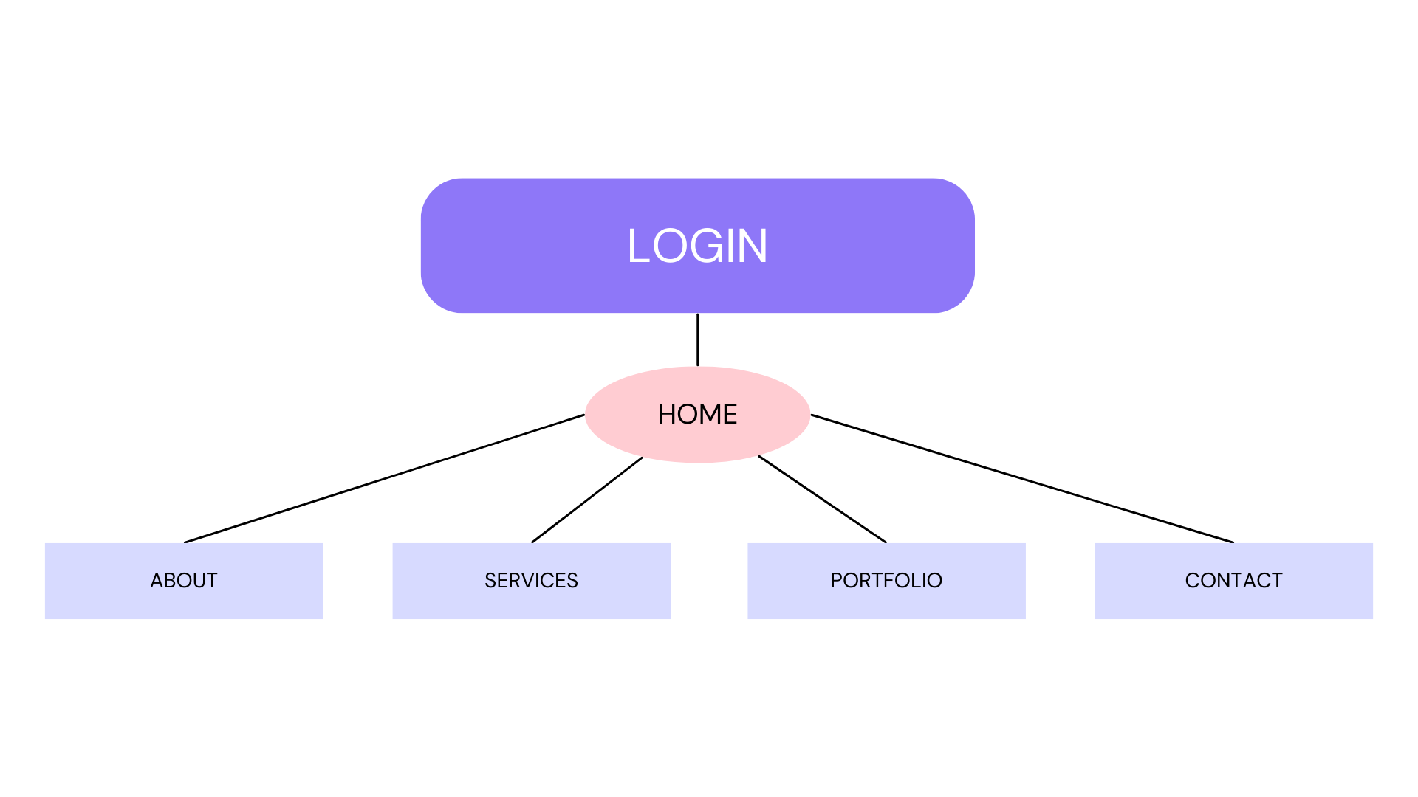

# POJECT DESCRIPTION

A polished, modern portfolio website to present my skills, projects, and professional journey as a web designer. The website is designed with a clean, minimal aesthetic to keep the focus on my work, while incorporating interactive elements that make exploring the site enjoyable.

The goal was to create a dynamic and responsive platform that captures my design approach and technical capabilities, helping potential clients or collaborators get a clear sense of my expertise and style.

**Key Features:**

* **Smooth Transitions and Animations:** Using CSS transitions and hover effects to bring a touch of interactivity, making navigation intuitive and engaging.
* **Responsive Design:** Optimized layouts and elements for seamless viewing on desktops, tablets, and mobile devices, ensuring accessibility across all screen sizes.
* **Showcase of Projects:** An organized project gallery highlighting each piece of work with descriptions, technologies used, and unique contributions.
* **Personal Branding Elements:** Custom logo and color scheme that reflects my unique style and professional brand, making the site memorable.

# POJECT OBJECTIVE

The objective of this personal portfolio website is to create a comprehensive, visually engaging, and user-friendly platform that effectively showcases my skills, projects, and professional background as a web designer. This website aims to demonstrate my expertise in web design, provide a clear representation of my design style, and serve as an interactive space for potential clients or collaborators to explore my work and get in touch for future opportunities.

# EXPECTED OUTCOMES

• **Enhanced Professional Visibility:** By presenting my work in a polished, interactive format, the website will increase my online presence, making it easier for potential clients, employers, and collaborators to find and assess my skills and projects.

• **Increased Client Engagement:** The clean, user-friendly design, along with detailed project showcases, is expected to engage visitors, encouraging them to explore my work further and ultimately reach out for design projects or collaborations.

• **Demonstration of Skills and Expertise:** The portfolio will serve as a concrete demonstration of my web design abilities, showcasing my proficiency in responsive design, UI/UX principles, and modern web development tools, establishing my credibility in the industry.

• **Expanded Professional Network:** Through the contact form and social media integrations, the website will help me build connections with other professionals in the field, expanding my network and opening doors to new opportunities.

• **Improved Personal Branding:** The portfolio will contribute to the growth of my personal brand, reflecting my design philosophy and unique style, which will set me apart from others in the competitive web design market.

# INDEX.HTML

<!DOCTYPE html>

<html lang="en">

<head>

    <meta charset="UTF-8">

    <meta name="viewport" content="width=device-width, initial-scale=1.0">

    <title>Personal Portfolio Website

    </title>

    <link rel="stylesheet" href="style.css">

    <script src="https://kit.fontawesome.com/3dcbbaa212.js" crossorigin="anonymous"></script>

</head>

<body>

    <div id="header">

        <div class="container">

            <nav>

                <img src="personal-portfolio-img/images/logoo.png" height="107" width="243" class="logoo">

                <ul id="sidemenu">

                    <li><a href="#header"><span>Home</span></a></li>

                    <li><a href="#About"><span>About</span></a></li>

                    <li><a href="#Services"><span>Services</span></a></li>

                    <li><a href="#Portfolio"><span>Portfolio</span></a></li>

                    <li><a href="#contact"><span>Contact</span></a></li>

                    <i class="fas fa-times" onclick="closemenu()"></i>

                </ul>

                <i class="fas fa-bars" onclick="openmenu()"></i>

            </nav>

            <div class="header-text">

                <h1>Hello, my name is <span>Om Hari</span> </h1>

                <h2>I'm a <span class="typing">UI/UX Designer</span></h2>

            </div>

        </div>

    </div>

About

 <div id="About">

        <div class="container">

            <div class="row">

                <div class="about-col-1">

                    <img src="personal-portfolio-img/images/my img.jpg" >

                </div>

                <div class="about-col-2">

                    <h1 class="sub-title">About Me</h1>

                    <p>I’m Om Hari Shukla, a passionate Web Designer with a knack for creating visually appealing and user-centered websites and mobile apps. I thrive on blending creativity with technical expertise to bring ideas to life in the digital space.

                        With experience in UI/UX design, responsive layouts, and accessibility best practices, I design interfaces that don’t just look good but also provide a smooth, enjoyable experience for users. I believe that every project, big or small, is an opportunity to create something unique that connects with people on a deeper level. </p>

                    <div class="tab-titles">

                        <p class="tab-links active-links" onclick="opentab('skills')">Skills</p>

                        <p class="tab-links" onclick="opentab('Experience')">Experience</p>

                        <p class="tab-links" onclick="opentab('Education')">Education</p>

                    </div>

                    <div class="tab-contents active-tab" id="skills">

                        <ul>

                            <li><span>UI/UX</span><br>Designing Web/App interfaces </li>

                            <li><span>Web Development</span><br>Designing Web Development </li>

                            <li><span>App Development</span><br>Building Android/ios Apps</li>

                        </ul>

                    </div>

                    <div class="tab-contents" id="Experience">

                        <ul>

                            <li><span>2024-Current</span><br>UI/UX Design Training at tokio Institute </li>

                            <li><span>2022-2024</span><br>Team lead at StarApp LLC </li>

                            <li><span>2020-2022</span><br>Internship at ekart eCommerce</li>

                        </ul>

                    </div>

                    <div class="tab-contents" id="Education">

                        <ul>

                            <li><span>2016</span><br>UI/UX Design Training at ET Institute</li>

                            <li><span>2018</span><br>M.Tech from IIT kanpur </li>

                            <li><span>2016</span><br>B.Tech from Lovely Professional University</li>

                        </ul>

                    </div>

                </div>

            </div>

        </div>

    </div>

Services

 <div id="Services">

        <div class="container">

            <h1 class="sub-title">My Services</h1>

            <div class="services-list">

                <div>

                    <i class="fa-solid fa-code"></i>

                    <h2>Web Design</h2>

                    <p>Responsive Design,User-Centered Design, HTML, CSS, JavaScript Proficiency, UI/UX Expertise, Adobe XD, Figma, Sketch, SEO Optimization , Accessibility-First Approach, Cross-Browser Compatibility . </p>

                    <a href="#">Learn more</a>

                </div>

                <div>

                    <i class="fa-solid fa-crop"></i>

                    <h2>UI/UX Design</h2>

                    <p> Focusing on seamless user experiences with clean, intuitive interfaces.Crafting designs that look and work great on any device, ensuring a consistent experience.Designing with inclusivity in mind, making sure interfaces are usable for everyone.

                    </p>

                    <a href="#">Learn more</a>

                </div>

                <div>

                    <i class="fa-brands fa-app-store-ios"></i>

                    <h2>App Design</h2>

                    <p>User-Centered Mobile Design,Interactive Prototyping , Designing for iOS and Android with platform-specific guidelines while maintaining a unified brand experience.Accessibility in Mobile, Data-Driven Design . </p>

                    <a href="#">Learn more</a>

                </div>

            </div>

        </div>

     </div>

Portfolio

      <div id="Portfolio">

        <div class="container">

            <h1 class="sub-title">My Work</h1>

            <div class="work-list">

                <div class="work">

                    <img src="personal-portfolio-img/images/work-1.png">

                    <div class="layer">

                        <h3>Social Media App</h3>

                        <p><h5> Key Features:</h5>

                            <ul><li>User-centered layout for profiles, feeds, and notifications</li>

                            <li>Consistent and clear visual hierarchy for easy navigation</li>

                            <li>Responsive design with adaptive mobile and desktop layouts</li></ul> </p>

                        <a href="#"><i class="fa-solid fa-arrow-up-right-from-square"></i></a>

                    </div>

                </div>

                <div class="work">

                    <img src="personal-portfolio-img/images/work-2.png">

                    <div class="layer">

                        <h3>Music App</h3>

                        <p><h5> Key Features:</h5>

                            <ul><li>Visually engaging player with easy access to playlists, albums, and favorites</li>

                            <li>Personalized recommendations for music discovery</li>

                            <li>Interactive animations and transitions to enhance the listening experience</li></ul> </p>

                        <a href="#"><i class="fa-solid fa-arrow-up-right-from-square"></i></a>

                    </div>

                </div>

                <div class="work">

                    <img src="personal-portfolio-img/images/work-3.png">

                    <div class="layer">

                        <h3>Online Shopping App</h3>

                        <p><h5> Key Features:</h5>

                            <ul><li>Intuitive navigation with categories, filters, and search options</li>

                            <li>Streamlined checkout with multiple payment methods</li>

                            <li>Consistent branding and style for a cohesive shopping experience across devices</li></ul> </p>

                        <a href="#"><i class="fa-solid fa-arrow-up-right-from-square"></i></a>

                    </div>

                </div>

            </div>

            <a href="#" class="btn">See more</a>

            <a href="hireme.html"target="_blank"class="btn btn3">Hire Me</a>

        </div>

    </div>

Contact

  <div id="contact">

        <div class="container">

            <div class="row">

                <div class="contact-left">

                    <h1 class="sub-title">Contact Me</h1>

                    <h3>I'm very responsive at messages</h3>

                    <p> <i class="fa-solid fa-paper-plane"></i> <strong>omharishukla66@gmail.com</strong></p>

                    <p><i class="fa-solid fa-square-phone"></i> <strong>9005923222</strong></p>

                    <div class="social-icon">

                        <a href="https://www.facebook.com/omhari.shukla.315/"><i class="fa-brands fa-facebook"></i></a>

                        <a href="https://www.instagram.com/om_hari_shukla/"><i class="fa-brands fa-square-instagram"></i></a>

                        <a href="https://www.linkedin.com/in/om-hari-shukla-5a1b742b3/"><i class="fa-brands fa-linkedin"></i><a>

                        <a href="https://x.com/OmhariShukla4"><i class="fa-brands fa-x-twitter"></i><a>

                    </div>

                    <a href="personal-portfolio-img/images/my-cv.pdf" download class="btn btn2">Donwnload CV</a>

                </div>

                <div class="contact-right">

                    <form name="submit-to-google-sheet">

                        <input type="text" name="Name" placeholder="Your Name" required>

                        <input type="email" name="Email" placeholder="Your Email" required>

                        <textarea name="Message" rows="6" placeholder="Your Message"></textarea>

                        <button type="submit" class="btn btn2">Submit</button>

                    </form>

                    <span id="msg"></span>

                </div>

            </div>

        </div>

        <div class="copyright">

            <p><b>Copyright @ 2024 <i class="fa-solid fa-heart"> </i>  All Right Reserved by Om Hari.</b></p>

        </div>

     </div>

JavaScript

<script>

    var tablinks = document.getElementsByClassName("tab-links")

    var tabcontents = document.getElementsByClassName("tab-contents")

    function opentab(tabname){

        for(tablink of tablinks){

            tablink.classList.remove("active-links");

        }

        for(tabcontent of tabcontents){

            tabcontent.classList.remove("active-tab");

        }

        event.currentTarget.classList.add("active-links");

        document.getElementById(tabname).classList.add("active-tab");

    }

</script>

<script>

    var sidemenu = document.getElementById("sidemenu");

    function openmenu(){

        sidemenu.style.right= "0";

    }

    function closemenu(){

        sidemenu.style.right= "-200px";

    }

</script>

<script>

    const scriptURL = 'https://script.google.com/macros/s/AKfycbxsfHC8Ei0Dp2Y1uEtAXeshlUWGzQ19yiYZlCGKaScoScdb8Hiby9IAttGvAZMkEMk/exec'

    const form = document.forms['submit-to-google-sheet']

    const msg = document.getElementById('msg')

    form.addEventListener('submit', e => {

      e.preventDefault()

      fetch(scriptURL, { method: 'POST', body: new FormData(form)})

        .then(response => {

            msg.innerHTML="Message Sent Successfully"

        setTimeout(function(){

            msg.innerHTML = ""

        },5000)

        form.reset()

    })

        .catch(error => console.error('Error!', error.message))

    })

  </script>

  <!-- -------------------typing animation-------------------- -->

  <script src="https://cdnjs.cloudflare.com/ajax/libs/typed.js/2.1.0/typed.umd.js" integrity="sha512-+2pW8xXU/rNr7VS+H62aqapfRpqFwnSQh9ap6THjsm41AxgA0MhFRtfrABS+Lx2KHJn82UOrnBKhjZOXpom2LQ==" crossorigin="anonymous" referrerpolicy="no-referrer"></script>

  <script>

    var typed = new Typed(".typing",{

        strings:["","UI/UX Designer"],

        typeSpeed:100,

        BackSpeed:30,

        loop:true

    })

  </script>

</body>

</html>

CSS

*{

    margin: 0;

    padding: 0;

    font-family: 'poppins',sans-serif;

    box-sizing: border-box;

}

html{

    scroll-behavior: smooth;

}

body{

    background: #080808;

    color: #fff;

}

#header{

    width: 100%;

    height: 100vh;

    background-image: url(personal-portfolio-img/images/desktop-wallpaper-portfolio-thumbnail.jpg);

    background-size: cover;

    background-position: center;

}

.container{

    padding: 10px 10%;

}

nav{

    display: flex;

    /* so the image and link will be side by side */

    align-items: center;

    justify-content: space-between;

    flex-wrap: wrap;

}

.logoo{

    width: 140px;

}

nav ul li{

    display: inline-block;

    list-style: none;

    margin: 10px 20px;

    /* top and bottom and left -right */

}

nav ul li a{

    color: white;

    text-decoration: none;

    font-size: 18px;

    position: relative;

    font-weight: 600;

}

nav ul li a::after{

    content: '';

    width: 0;

    height: 3px;

    background: #ff004f;

    position: absolute;

    left: 0;

    bottom: -6px;

    transition: 0.5s ;

}

/* -------------ye apni sajawat hai----------------- */

#sidemenu span:hover{

    color: #ff004f;

}

#sidemenu span{

    transition: color 0.3s ease;

}

/* --------------------bas rukle--------------- */

nav ul li a:hover::after{

    width: 100%;

}

.header-text{

    margin-top: 20%;

    font: size 20px;

}

.header-text h1{

    font-size: 55px;

    margin-top: 20px;

}

.header-text h2{

    margin-top: 20px;

    font-size: 4cap;

}

.header-text h2 span{

    color: #ff004f;

    font-family: 'Clicker Script' , cursive;

}

.header-text h1 span{

    color: #ff004f;

    font-family: 'Clicker Script' , Cambria, Cochin, Georgia, Times, 'Times New Roman', serif;

}

/* -----------------about -------------- */

#About{

    padding: 80px 0;

    color: #ababab;

}

.row{

    display: flex;

    justify-content: space-between;

    flex-wrap: wrap;

}

.about-col-1{

    flex-basis: 35%;

    /* it means width of the columns */

}

.about-col-1 img{

    width: 100;

    border-radius: 15px;

    height: 500px;

}

.about-col-2{

    flex-basis: 60%;

}

.sub-title{

    font-size: 60px;

    font-weight: 600;

    color: #fff;

}

.tab-titles{

    display: flex;

    margin: 20px 0 40px;

}

.tab-links{

    margin-right: 50px;

    font-size: 22px;

    font-weight: 550;

    cursor: pointer;

    position: relative;

    color: lightgrey;

}

.tab-links::after{

    content: '';

    width: 0;

    height: 3px;

    background: #ff004f;

    position: absolute;

    left: 0;

    bottom: -8px;

    transition: 0.5s;

}

.tab-links.active-links::after{

    width: 50%;

}

.tab-contents ul li{

    list-style: none;

    margin: 10px 0;

}

.tab-contents ul li span{

    color: #b54769;

    font-size: 20px;

}

.tab-contents{

    display: none;

}

.tab-contents.active-tab{

    display: block;

}

/* ----------Services------ */

#Sevices{

    padding: 30px 0;

}

.services-list{

    display: grid;

    grid-template-columns: repeat(auto-fit, minmax(250px, 1fr));

    grid-gap: 40px ;

    margin-top: 50px;

}

.services-list p{

    margin: 10px;

}

.services-list a{

    font-weight: 700;

}

.services-list a:hover{

    color: #0000EE;

}

.services-list div{

    background-color: #262626;

    padding: 40px;

    font-size: 13px;

    font-weight: 300;

    border-radius: 10px;

    transition: background 0.5s, transform 0.5s;

}

.services-list div i{

    font-size: 50px;

    margin-bottom: 30px ;

}

.services-list div i h2{

    font-size: 30px;

    font-weight: 500;

    margin-bottom: 15px;;

}

.services-list div a{

    text-decoration: none ;

    color: #fff;

    font-size: 12px;

    margin-top: 20px;

    display: inline-block;

}

.services-list div:hover{

    background: #ff004f;

    transform: translateY(-10px);

}

/* -----------PORTFOLIO--------- */

#Portfolio{

    padding: 50px 0;

}

.work-list{

    display: grid;

    grid-template-columns: repeat(auto-fit, minmax(250px, 1fr));

    grid-gap: 40px ;

    margin-top: 50px;

}

.work{

    border-radius: 10px;

    position: relative;

    overflow: hidden;

}

.work img{

    width: 100%;

    border-radius: 10px;

    display: block;

    transition: transform 0.5s;

}

.layer{

    width: 100%;

    height: 0;

    background: linear-gradient(rgba(0,0,0,0.6),#ff004f);

    border-radius: 10px;

    position: absolute;

    left: 0;

    bottom: 0;

    overflow: hidden;

    display: flex;

    align-items: center;

    justify-content: center;

    flex-direction: column;

    padding: 0 40px;

    text-align: center;

    font-size: 14px;

    transition: height 0.5s;

}

.layer h3{

    font-weight: 500;

    margin-bottom: 20px;

}

.layer h5{

    margin: 10px;

}

.layer a{

    margin-top: 20px;

    color: red;

    text-decoration: none;

    font-size: 18px;

    line-height: 60px;

    background: #fff;

    width: 60px;

    height: 60px;

    border-radius: 50%;

    text-align: center;

}

.work:hover img{

    transform: scale(1.1);

}

.work:hover .layer{

    height:100% ;

}

.btn{

    display: block;

    margin: 50px auto;

    width: fit-content;

    border: 1px solid #ff004f ;

    padding: 14px 50px;

    border-radius: 6px;

    text-decoration: none;

    color: #fff;

    transition: background 0.5s;

}

.btn:hover{

    background: #ff004f;

}

.btn.btn3{

    display: block;

    margin: 50px auto;

    width: fit-content;

    border: 1px solid #ff004f ;

    padding: 14px 50px;

    border-radius: 6px;

    text-decoration: none;

    background-color: #ff004f;

}

/* ---------------CONTACT----------------------- */

.contact-left{

    flex-basis: 35%;

}

.contact-left h3{

    margin-top:20px ;

    color: lightcoral;

    text-decoration: underline;

}

.contact-right{

    flex-basis: 60%;

}

.contact-left p{

    margin-top: 30px;

}

.contact-left p i{

    color: #ff004f;

    margin-right: 15px;

    font-size: 25px;

}

.social-icon{

    margin-top: 30px;

}

.social-icon a{

    text-decoration: none;

    font-size: 30px;

    margin-right: 15px;

    display: inline-block;

    color: #ababab;

    transition: transform 0.5s;

}

.social-icon a:hover{

    color: #ff004f;

    transform: translateY(-5px);

}

.btn.btn2{

    display: inline-block;

    background: #ff004f;

}

.contact-right form{

    width: 100%;

}

form input, form textarea{

    width: 100%;

    border: 0;

    outline: none;

    background: #262626;

    padding: 15px;

    margin: 15px 0;

    color: #fff;

    font-size: 18px;

    border-radius: 6px;

}

form .btn2{

    padding: 14px 60px;

    font-size: 18px;

    margin-top: 20px;

    cursor: pointer;

}

.copyright{

    width: 100%;

    text-align: center;

    padding: 25px 0;

    font-weight: 300;

    margin-top: 20px;

}

.copyright i{

    color: #ff004f;

}

/* -------------css for small screen----------------- */

nav .fas{

     display: none ;

}

@media only screen and (max-width: 600px){

    #header{

        background-image: url(personal-portfolio-img/images/bgg.jpg);

    }

    .header-text{

        margin-top: 100%;

        font-size: 16px;

    }

    .header-text h1{

        font-size: 30px;

    }

    nav .fas{

        display: block ;

        font-size: 25px;

    }

    nav ul{

        background: #ff004f;

        position: fixed;

        top: 0;

        right: -200px;

        width: 200px;

        height: 100vh;

        padding-top: 50px ;

        z-index: 2;

        transition: right 0.4s;

    }

    nav ul li{

        display: block;

        margin: 25px;

    }

    nav ul .fas{

        position: absolute;

        top: 25px;

        left: 25px;

        cursor: pointer;

    }

    .sub-title{

        font-size: 40px;

    }

    .about-col-1, .about-col-2{

        flex-basis: 100%;

    }

    .about-col-1{

        margin-bottom: 30px;

    }

    .about-col-2{

        font-size: 14px;

    }

    .tab-links{

        font-size: 16px;

        margin-right: 20px;

    }

    .contact-left, .contact-right{

        flex-basis: 100%;

    }

    .copyright{

        font-size: 14px;

    }

}

#msg{

    color: #61b752;

    margin-top: -40px;

    display: block;

}

Hire.html

<!DOCTYPE html>

<html lang="en">

<head>

    <meta charset="UTF-8">

    <meta name="viewport" content="width=device-width, initial-scale=1.0">

    <title>Hire Me</title>

    <style>

        * {

    box-sizing: border-box;

    margin: 0;

    padding: 0;

    font-family: Arial, sans-serif;

}

body {

    background-color: #f7f7f7;

    color: #000000;

}

.container {

    max-width: 800px;

    margin: 50px auto;

    padding: 20px;

    background-color: #fff;

    box-shadow: 0 4px 8px rgba(0, 0, 0, 0.1);

    border-radius: 8px;

}

h1 {

    color: #000000;

    text-align: center;

    margin-bottom: 20px;

}

h2 {

    color: #000000;

    margin-top: 20px;

}

p, ul {

    margin-bottom: 15px;

}

ul {

    list-style-type: disc;

    padding-left: 20px;

}

form {

    display: flex;

    flex-direction: column;

}

label {

    font-weight: bold;

    margin-top: 10px;

}

input, textarea {

    padding: 10px;

    margin-top: 5px;

    border: 1px solid #ddd;

    border-radius: 4px;

}

.hire-btn {

    margin-top: 20px;

    padding: 12px;

    background-color:black;

    color: #fff;

    border: none;

    border-radius: 4px;

    cursor: pointer;

    font-size: 16px;

    transition: background-color 0.3s;

}

.hire-btn:hover {

    background-color: #ff004f;

}

    </style>

</head>

<body>

    <div class="container">

        <h1>Looking for a Creative Designer?</h1>

        <p>I am a web designer ready to bring your vision to life! Whether you need a full website redesign, a fresh new logo, or CSS transitions that captivate, I’m here to help.</p>

        <h2>What I Offer</h2>

        <ul>

            <li>Custom Website Design</li>

            <li>Responsive Web Development</li>

            <li>Logo & Branding</li>

            <li>UI/UX Enhancements</li>

            <li>CSS Animations & Transitions</li>

        </ul>

        <h2>Contact Me</h2>

        <p>Ready to discuss your project? Fill out the form below, and let’s get started!</p>

        <form action="submit_form.php" method="post">

            <label for="name">Your Name</label>

            <input type="text" id="name" name="name" required>

            <label for="email">Your Email</label>

            <input type="email" id="email" name="email" required>

            <label for="message">Message</label>

            <textarea id="message" name="message" rows="4" required></textarea>

            <button type="submit" class="hire-btn">Hire Me</button>

        </form>

    </div>

</body>

</html>

# OUTPUT SCREENSHOT

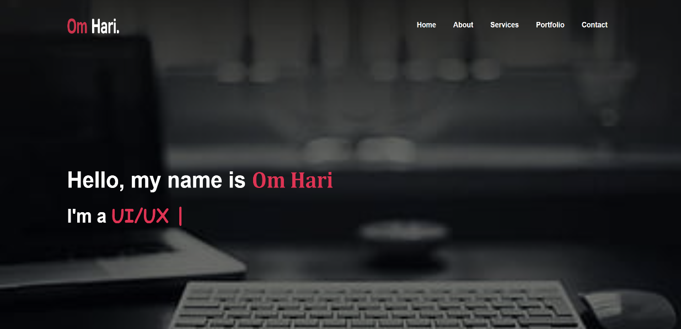

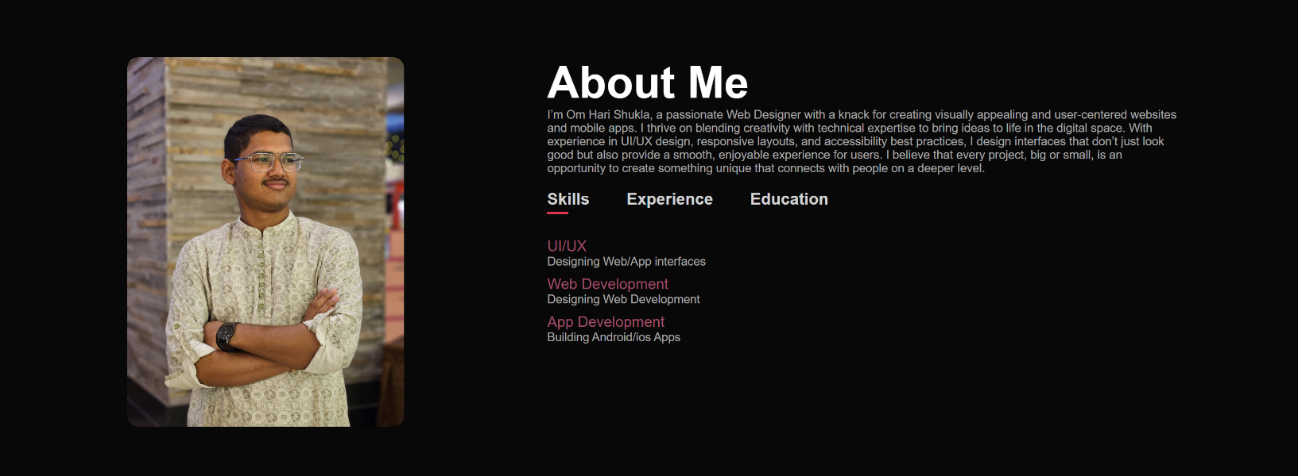

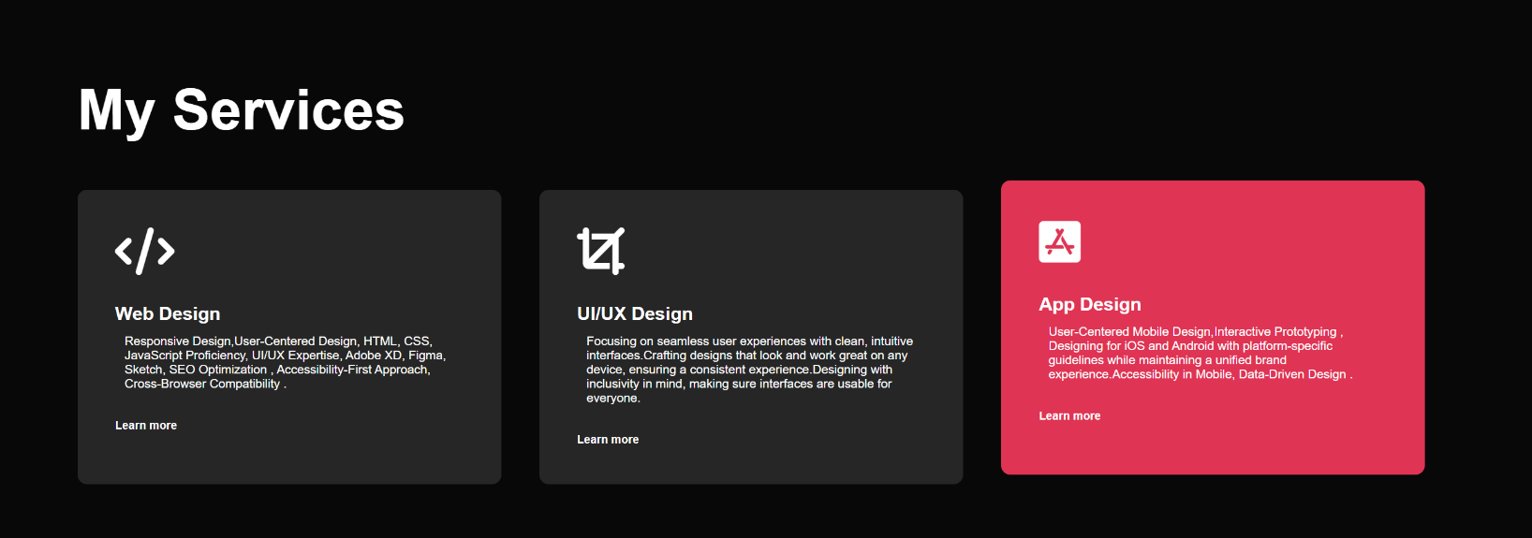

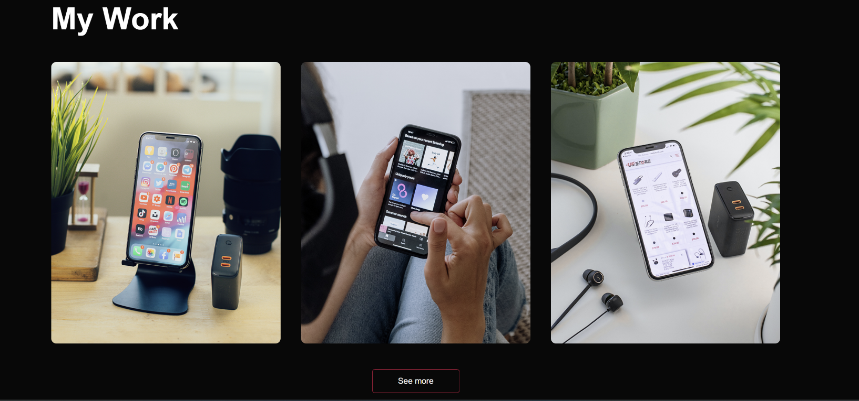

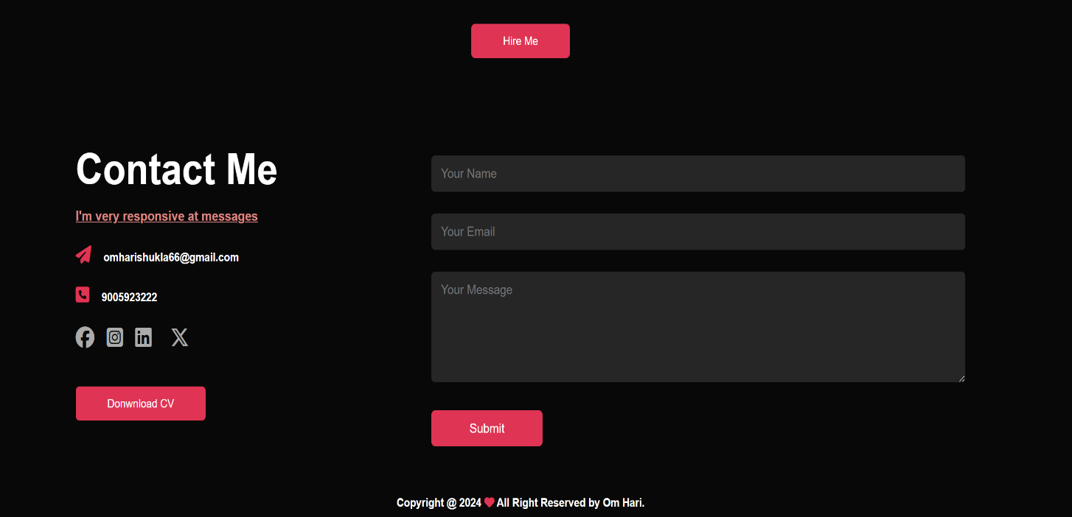

GTIHUB LINK

CONCLUSION

Thank you for taking the time to explore my work and learn more about my journey as a web designer. This portfolio reflects not only my skills and expertise but also my passion for creating impactful digital experiences. I am excited to connect with like-minded professionals, potential clients, and collaborators who share my vision for innovative design. Please feel free to reach out—whether you have a project in mind or simply want to chat, I’d love to hear from you.

REFERENCES

* W3School